SIMATS ENGINEERING
ASSESSMENT TOOL 1

COURSE NAME: Ethical Hacking COURSE CODE: ITA14

COURSE OUTCOME COVERED

CO2: Execute footprinting in social engineering such as DNS analysis, competitive intelligence gathering, and attack simulations to collect relevant information for identifying potential security risks.

Assessment Tool Weightage: 30%

Duration: 90 min Total Marks: 50

Report Analysis
Questions

- A security analyst performed a network scan on the target 192.168.1.10 using the Nmap tool. The report identified several open ports, including HTTP (80), SSH (22), and MySQL (3306), along with the operating system and service versions. Analyze the report and explain the security risks associated with the identified services. Discuss how an attacker could exploit these services and recommend suitable security measures to protect the target system. (20 Marks)
1. Introduction
Nmap (Network Mapper) is an open-source network scanning tool used by cybersecurity professionals to discover active hosts, identify open ports, detect running services, determine service versions, and estimate the target operating system.
A port is a logical communication endpoint through which applications send and receive network traffic. An open port indicates that a service is listening for connections; it does not automatically mean that the service is vulnerable.
In this case, the security analyst scanned the target system 192.168.1.10 and identified HTTP on port 80, SSH on port 22, and MySQL on port 3306. Nmap's service-version detection can help analysts identify software that needs further security investigation.
OS details: Linux (estimated)
Illustrative output only. Actual service versions and operating-system results must come from the real scan.

3. Analysis of Identified Ports and Services
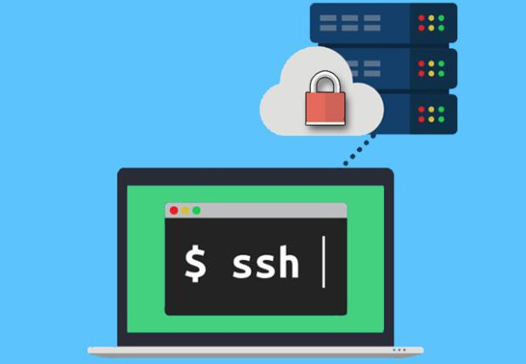

A. SSH — Port 22
SSH is used for secure remote login, command execution, and server administration.
Security risks
- Brute-force attempts against weak passwords.
- Stolen passwords or private keys.
- Vulnerabilities in outdated SSH software.
- Excessive administrator privileges.
Possible exploitation: An attacker who obtains valid credentials or exploits a genuine software flaw may gain unauthorized remote access.
Countermeasures: Use SSH keys, MFA where supported, disable direct root login, restrict access by firewall, patch the service, and monitor failed logins.

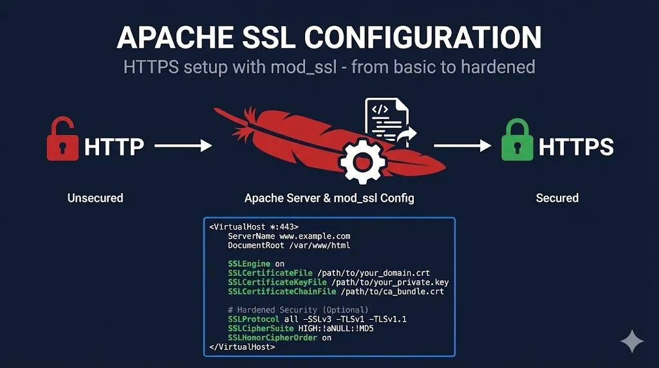
B. HTTP — Port 80
HTTP allows users to access websites and web applications.
Security risks
- Ordinary HTTP traffic is not encrypted.
- SQL injection through vulnerable application inputs.
- Cross-site scripting (XSS).
- Directory traversal and unauthorized file access.
- Outdated web server software.
Possible exploitation: An attacker may manipulate a vulnerable web form, steal exposed session information, or attempt to access files without authorization.
Countermeasures: Enforce HTTPS, update the web server, validate inputs, use parameterized SQL queries, apply a Web Application Firewall (WAF), and test web applications regularly.
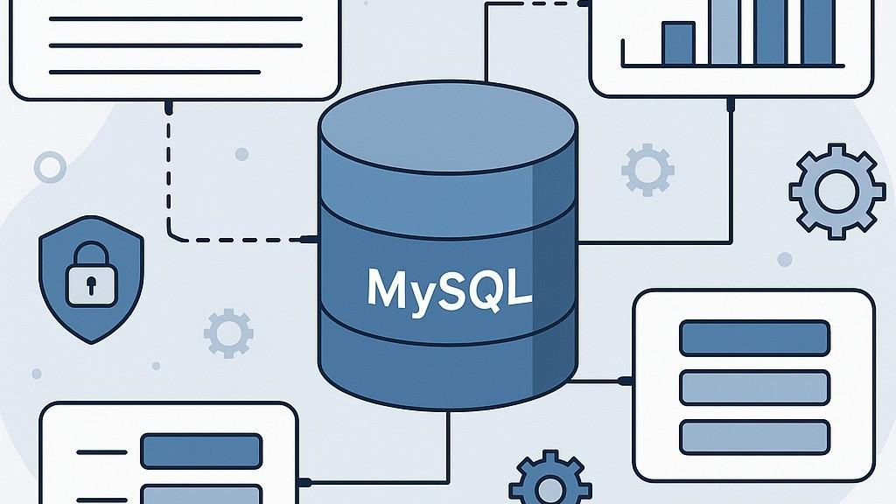

MySQL stores structured information such as user accounts, transactions, and application records.
Security risks
- Weak database passwords.
- Exposure of the database to untrusted networks.
- Unauthorized reading, modification, or deletion of records.
- Excessive database account privileges.
- SQL injection through a vulnerable application.
Possible exploitation: If the database is reachable by an unauthorized party and authentication or access controls are weak, the attacker may attempt to retrieve or alter sensitive records.
Countermeasures: Restrict access to trusted application servers, use strong credentials, apply least privilege, encrypt database connections, patch MySQL, audit activity, and protect backups.

5. Diagram: How an Attacker Might Exploit the Findings
Step 1 — Reconnaissance
Discover open ports and identify service versions.
Step 2 — Weakness identification
Check for outdated software, insecure settings, and weak authentication.
SSH
Remote access risk
HTTP
Web attack risk
MySQL
Step 3 — Possible consequences
Unauthorized access, data theft, data alteration, or service disruption.
6. General Security Recommendations
- Disable unnecessary services and close unused ports.
- Configure firewall rules to allow only required connections.
- Patch the operating system, SSH, web server, and database software.
- Use strong authentication, MFA where appropriate, and least-privilege access.
- Perform authorized vulnerability assessments periodically.
- Monitor system logs and deploy intrusion detection or endpoint protection.
- Maintain protected backups and regularly test recovery procedures.
7. Conclusion
The Nmap scan identifies three exposed services that require different security controls. SSH requires strong remote-access protection, HTTP requires secure web communication and application testing, and MySQL requires strict database access controls. Combining patch management, firewalls, authentication, monitoring, and regular assessments reduces the likelihood of a successful attack.
- A phishing awareness campaign was conducted for employees of ABC Technologies Pvt. Ltd. using the GoPhish tool. The report indicates that 40% of employees clicked the phishing link, 20% entered their login credentials, and several users downloaded a malicious attachment. Analyze the report and identify the security weaknesses demonstrated by the employees. Recommend suitable user awareness programs, email security controls, and organizational policies to reduce the risk of successful social engineering attacks.(20 Mark)
Phishing is a social engineering technique in which attackers send fraudulent emails or messages that appear to come from trusted sources. Their aim is to trick people into clicking malicious links, disclosing passwords, downloading harmful attachments, or transferring money.
GoPhish is a phishing simulation framework that helps organizations conduct authorized awareness campaigns. Its campaign reports can record email opens, link clicks, and submitted credentials, allowing security teams to identify areas where employee training is needed.

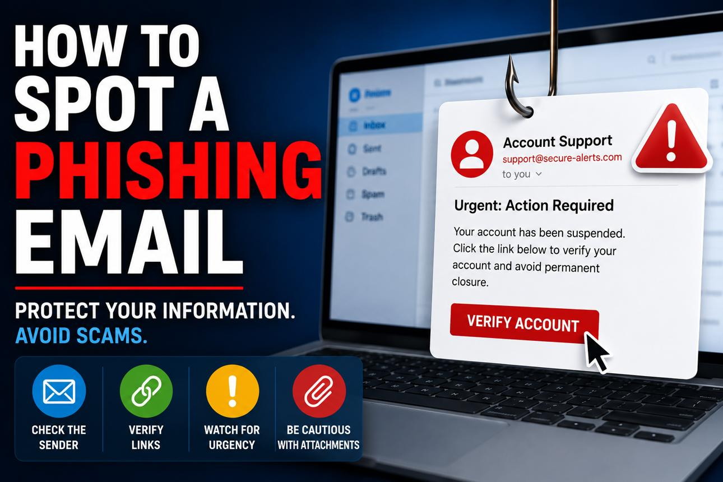
Subject: Urgent: Verify Your Account
Dear Employee,
Your account requires verification. Click the link below to confirm your account details.
[Suspicious verification link — example only]
Failure to respond immediately may result in account suspension.
Warning signs: urgency, an unexpected request, a link that requires verification, and a sender identity that should be checked independently.
This example demonstrates how attackers may use urgency and impersonation to encourage employees to act without verifying a message.
Analysis of the GoPhish Campaign Report
The report states that 40% of employees clicked a phishing link, 20% submitted their credentials, and several employees downloaded a malicious attachment.

Interpretation of the results
1. Forty percent clicked the link. This indicates that a substantial proportion of employees interacted with a suspicious link. It may reflect difficulty recognizing deceptive URLs, sender impersonation, or urgent requests.
2. Twenty percent submitted credentials. This demonstrates a serious risk of password disclosure. If real attackers obtained those credentials, they could attempt to access corporate accounts, email, or internal systems.
3. Several employees downloaded attachments. This suggests a need for stronger attachment-handling practices. Downloading a file does not necessarily mean malware executed, but it increases the need for investigation and appropriate endpoint safeguards.
4. Overall risk. The findings show that awareness alone may be insufficient without technical controls. Training, email filtering, identity protection, and incident reporting must work together.Security Weaknesses Demonstrated by Employees
How Attackers Could Exploit These Weaknesses
Step 1: Send a deceptive email
Impersonate IT support, management, a bank, or a trusted service.
Step 2: Encourage the employee to click
Use urgency, fear, curiosity, or a false reward.
Credential theft
Attempt to access the account using stolen login information.
Malware risk
Attempt to compromise a device through a malicious attachment.
Potential consequences
Account compromise, data theft, fraudulent transactions, ransomware, or business disruption.

Recommended User Awareness Programs
1. Regular cybersecurity training: Conduct sessions on phishing, social engineering, impersonation, and safe email usage.
2. Simulated phishing exercises: Repeat authorized GoPhish campaigns and provide immediate, constructive feedback to employees who interact with simulated attacks.
3. Email verification training: Teach staff to verify sender addresses, inspect links, and independently confirm unusual payment or password requests.
4. Attachment safety training: Educate employees about suspicious file types, unexpected documents, and the importance of approved scanning procedures.
5. Incident-reporting training: Provide a simple reporting button or dedicated reporting address and explain when to contact IT or the security team.
6. Role-based awareness: Give additional training to finance, HR, IT administrators, and employees who handle sensitive information.

Recommended Email Security Controls
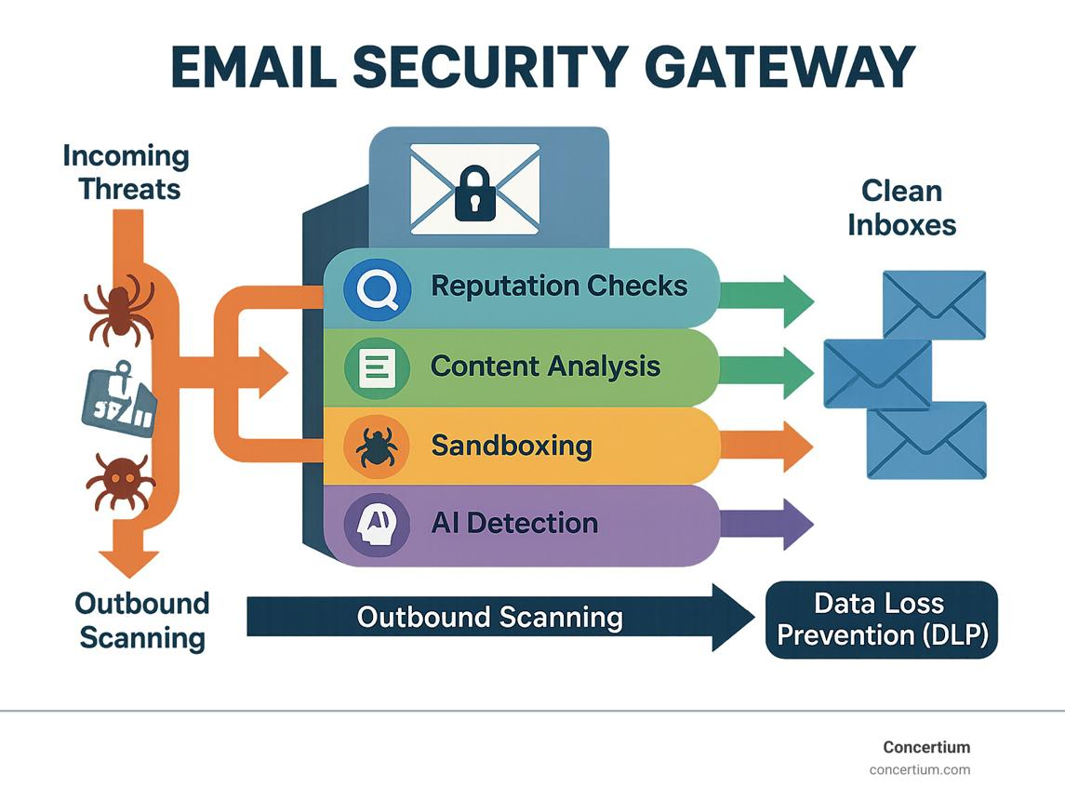
A. Email filtering and anti-phishing gateways
Detect suspicious messages, malicious URLs, impersonation attempts, and spam before they reach employees.
B. SPF, DKIM, and DMARC
Configure these email-authentication mechanisms to help detect unauthorized use of the organization's domain and reduce spoofing.
C. Attachment sandboxing and endpoint protection
Analyze suspicious files in an isolated environment and use endpoint security tools to detect malicious activity.
D. Multi-factor authentication
Require a second authentication factor for important accounts. Phishing-resistant methods, such as security keys or passkeys, provide stronger protection against credential theft.
Additional controls include URL filtering, browser protection, suspicious-login alerts, least-privilege access, and regular software updates.

Measuring Improvement
ABC Technologies should repeat simulations and compare campaign results over time. Useful indicators include link-click rates, credential-submission rates, attachment interactions, and the proportion of suspicious messages reported.
The organization should aim for fewer risky interactions and faster reporting. Employees should be encouraged to report mistakes promptly rather than hide them.

Conclusion
The GoPhish report demonstrates weaknesses in phishing recognition, link verification, credential protection, and attachment handling. ABC Technologies should combine regular employee training, secure email filtering, email authentication, MFA, endpoint protection, and clear reporting policies. These measures will help reduce successful social engineering attacks and improve the organization's overall security awareness
- A DNS assessment report generated using the Dig tool shows that the organization's DNS server permits a successful DNS Zone Transfer (AXFR), exposing internal hostnames, mail servers, and DNS records. Analyze the report and explain the security implications of the exposed information. Discuss how attackers could exploit these findings and recommend best practices to secure the DNS infrastructure..(10 Marks)
DNS (Domain Name System) translates domain names into IP addresses and helps locate services such as websites and mail servers. The dig command is a DNS diagnostic tool used to query DNS records and investigate DNS server configurations.
A DNS zone transfer, called AXFR, copies DNS zone records from an authoritative DNS server to an authorized secondary DNS server. If unauthorized clients can obtain the entire zone, sensitive infrastructure information may be disclosed.
3. DNS Record Types and Exposed Information
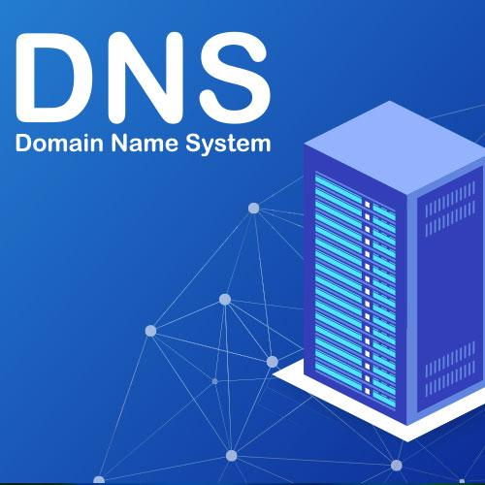
A. A and AAAA records
Map hostnames to IPv4 and IPv6 addresses. These records can reveal server addresses and potential targets for further investigation.
B. MX records
Identify mail servers responsible for receiving email. This information may help attackers plan targeted phishing or email infrastructure reconnaissance.
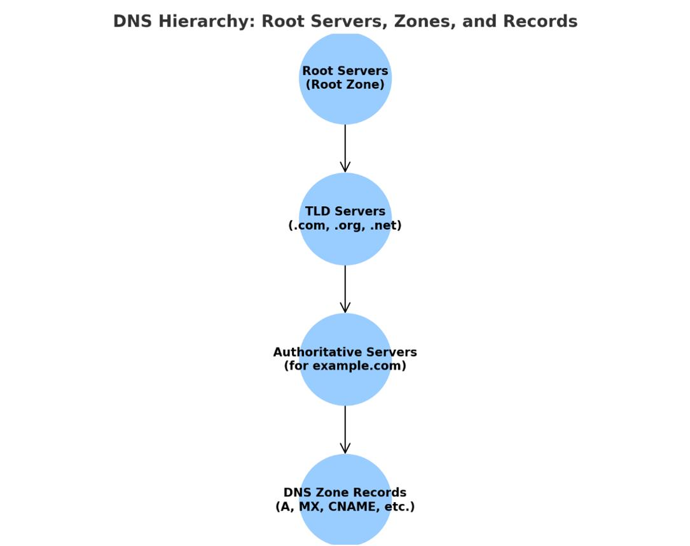
C. NS and SOA records
Identify authoritative name servers and provide information about zone authority and configuration.
D. Internal hostnames and aliases
May reveal development servers, internal naming conventions, or relationships between systems when such records are included in the transferred zone.
Security Implications
- Information disclosure: An unauthorized user may obtain a large collection of DNS records.
- Network reconnaissance: Hostnames and IP addresses can help an attacker understand the organization's infrastructure.
- Target identification: Records may identify mail servers, administrative services, or other systems worth investigating.
- Targeted phishing: Knowledge of real server names and organizational naming conventions may make deceptive messages more convincing.
- Increased attack surface: Disclosed records can make it easier to discover potentially exposed services and investigate their security.
A successful zone transfer does not automatically provide access to the listed servers or allow an attacker to change DNS records. The main immediate risk is information disclosure that supports subsequent attacks.
Diagram: How DNS Zone Transfer Exposure Works
Step 1: Unauthorized client
Requests a DNS zone transfer.
Step 2: Authoritative DNS server
Incorrectly permits the request instead of restricting it to authorized secondary servers.
Step 3: DNS records disclosed
Hostnames, IP addresses, mail servers, and other zone records may be exposed.
Step 4: Potential consequences
More effective reconnaissance and targeted attacks against identified systems.

Conclusion
The successful AXFR result indicates that the DNS server may be exposing infrastructure information to unauthorized clients. This information can help attackers perform reconnaissance and plan targeted attacks. Restricting zone transfers, separating internal and external DNS, monitoring requests, updating DNS software, and reviewing configurations are essential to secure the organization's DNS infrastructure.

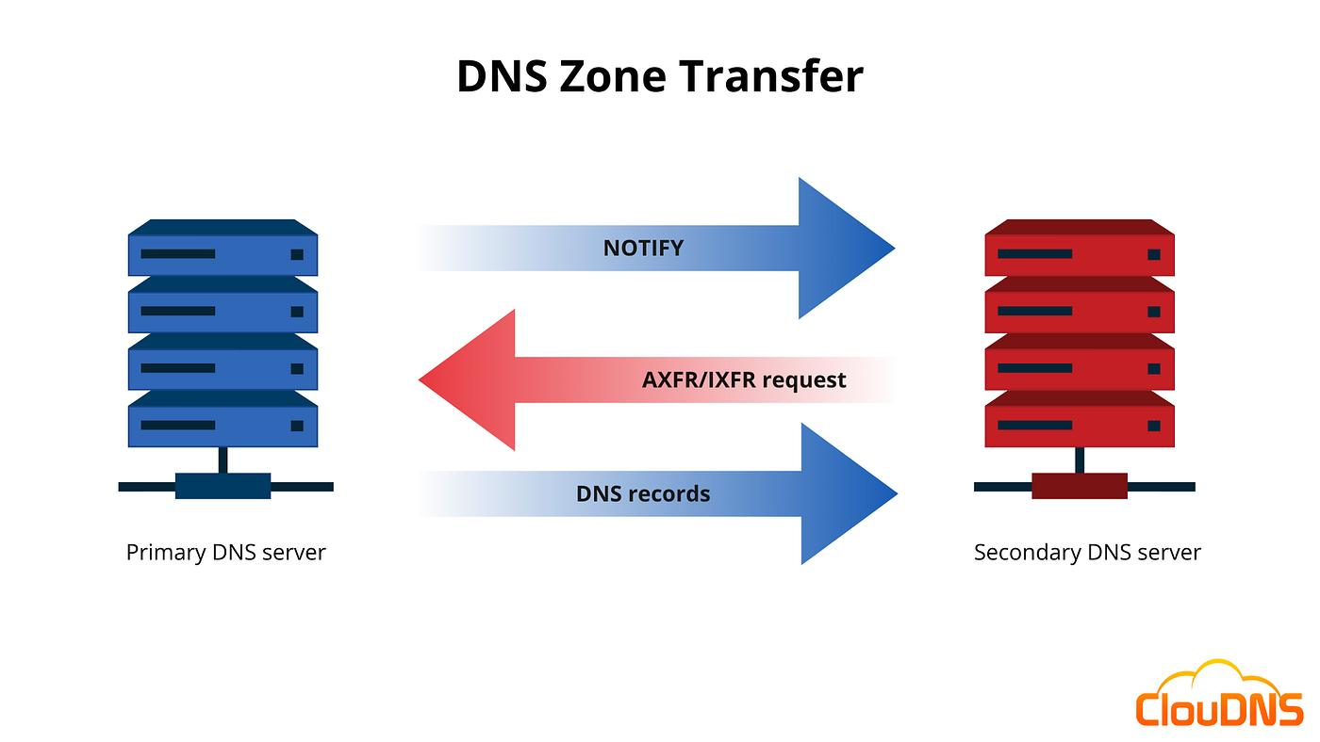

Code of Conduct:

I M.Supraja(192472301)(Name / Reg No) certify that this submission is my original work and that I have adhered to the guidelines specified for this assessment.
I understand that any violation of academic integrity rules will result in disciplinary action.

Signature of the student:M.Supraja

RUBRICS FOR CALCULATION

Report Analysis
Criteria | Weightage (%) | Level 4 (Exemplary) | Level 3 (Proficient) | Level 2 (Developing) | Level 1 (Beginning)
Report Analysis and Interpretation | 25% | Accurately interprets the security report, identifies all key findings, and explains their significance with excellent technical understanding. | Correctly interprets most findings with minor omissions or inaccuracies. | Identifies only some findings and provides limited interpretation. | Unable to interpret the report or identify key findings.
Identification of Security Risks and Vulnerabilities | 25% | Correctly identifies all security risks, vulnerabilities, and possible attack vectors with clear technical justification. | Identifies most risks and vulnerabilities with minor errors. | Identifies only a few risks with limited technical explanation. | Fails to identify major risks or vulnerabilities.
Application of Cybersecurity Concepts and Countermeasures | 30% | Applies appropriate ethical hacking concepts and recommends comprehensive, practical, and technically sound countermeasures. | Recommends suitable countermeasures with minor technical gaps. | Provides limited or partially appropriate recommendations. | Recommendations are inappropriate, incomplete, or missing.
Technical Communication and Documentation | 20% | Response is well-organized, technically accurate, clearly presented, and uses appropriate cybersecurity terminology throughout. | Response is organized and understandable with minor documentation or presentation issues. | Response lacks clarity, organization, or contains several technical inaccuracies. | Response is poorly organized, incomplete, and difficult to understand.

